# MVC ASSESSMENT BY SUNIA SULTANA

**1st QUESTION**

**1.ADD EF Core Packages**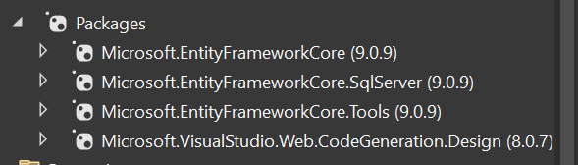

**Project Structure**

**2.Models/Student.cs**

**Models/Course.cs**

**3.Create DbContext**

**Data/ApplicationDbContext.cs**

**4.Configure Connection string(appsettings.json)**

**Program.cs**

**5.Run EF Core Migrations**

**6.Controllers**

**Controllers/StudentsController.cs**

**Controllers/CoursesController.cs**

**7.Create Views**

**8.Navigation**

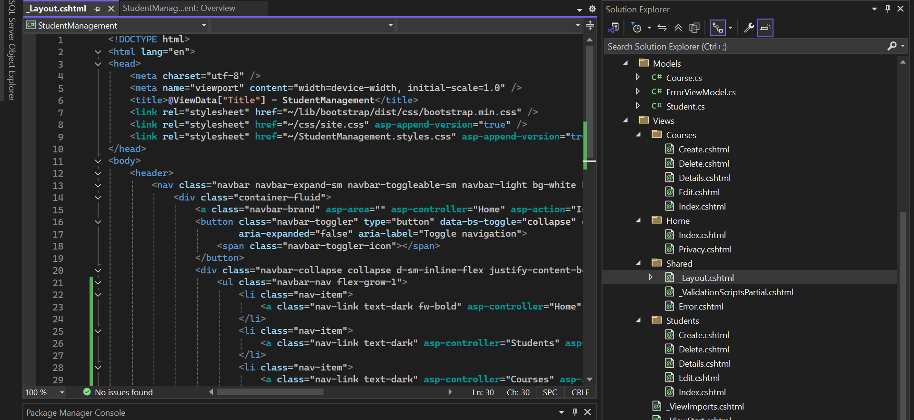

**OUTPUT-------------------**

**1.Dashboard**

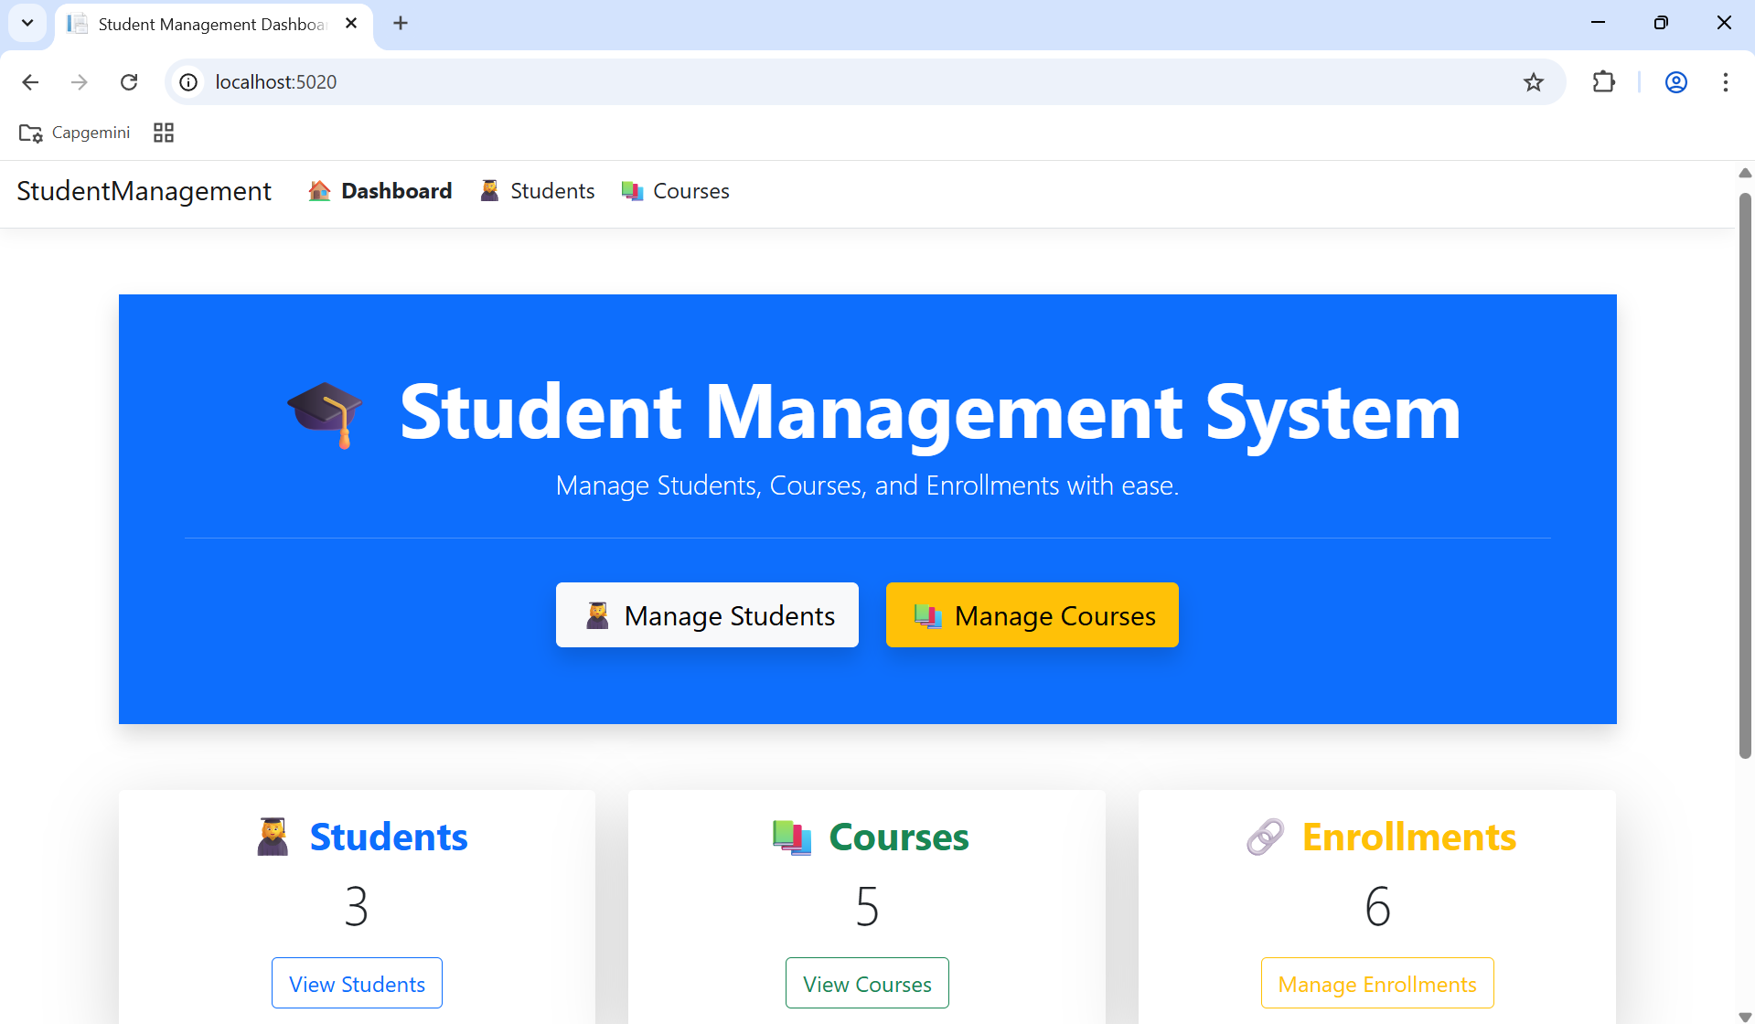

**2.Students Page**

**Add New Student**

**After Adding New Student**

**Edit Student**

**After Editing**

**3.Courses Page**

**2nd Question**

1. **Packages Installed**

**

1. **Create SQL Database and StoredProcedure**

**3.Configure Connection (appsettings.json)**

**Program.cs**

**4.Create Employee Model**

**Models/Employee.cs**

**5.Create DbContext**

**Data/ApplicationDbContext.cs**

**6.Create Controller to Call Stored Procedure**

**Controllers/EmployeesController.cs**

**7.Create Razor View**

**Views/Employees/HighSalary.cshtml**

**8.Run the Project**

[**http://localhost:5225/Employees/HighSalary?minSalary=50000**](http://localhost:5225/Employees/HighSalary?minSalary=50000)

**OUTPUT---------------**

**1.HomePage**

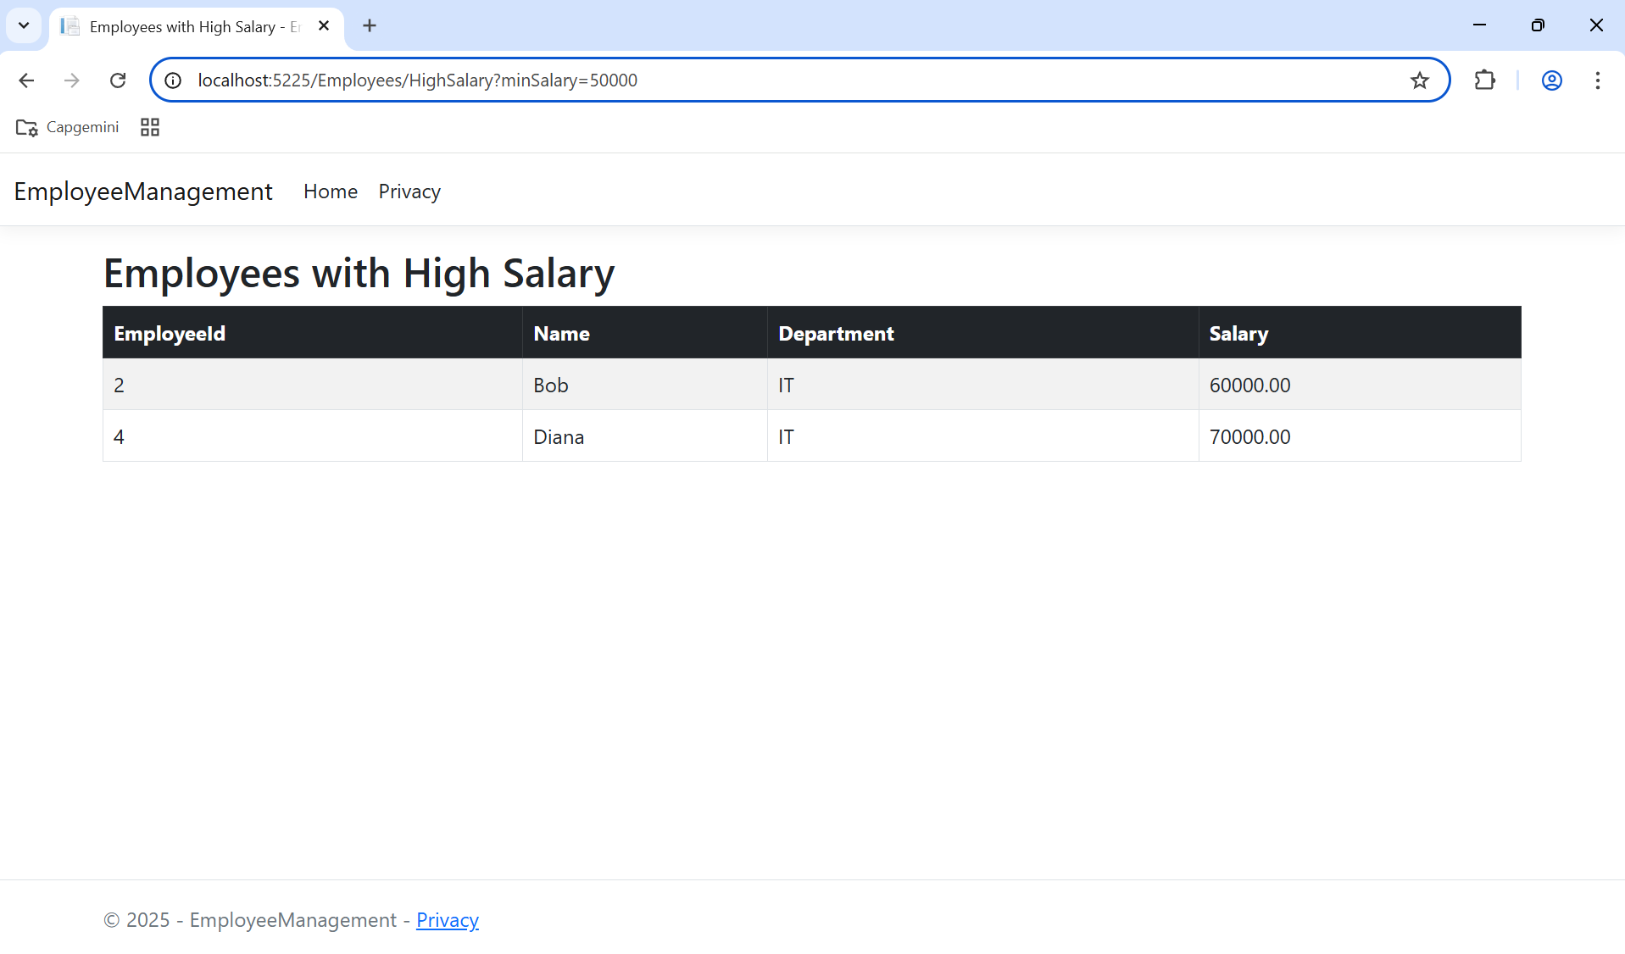

**All Employees Data**

